October 2019
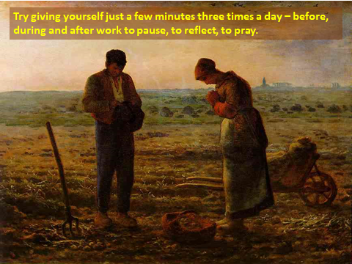
Dear God
Thank you for the tremendous opportunity to be a part of Cameley Primary School
To be making a positive difference to the lives of those around us
Thank you for the wonderful feeling I have when all is going well
Thank you for providing a source of light when things get messy
When cracks appear help me to be open with somebody
When cracks appear help me to be a source of light to somebody
When cracks appear let your light shine in
Thank you that your light directly, reflected through others or through me
Can make a positive difference to the lives of those around us.
Amen

Diary Dates
Friday October 4th – Theatre Trip Yr1-Yr6 (Letter to follow with details in term 1)
Monday 7th October – Governor Learning walk/monitoring visit
Tuesday 8th October - Swimming Yr1&2 (pm)
Wednesday 9th October – 10:45 -12:15pm Yr3&4 Invasion Festival @ CV School Cancelled
Wednesday 9th October – Yr3&4 Group Music session (pm)
Wednesday 9th October – EYFS Team Meeting (TBC)
Thursday 10th October – Rowan Class Egyptologist Workshop (all day)
Thursday 10th October - Rock Steady Singing and Music session (am)
Friday 11th October – 9:30am Commendations Assembly
Monday 14th October – Cameley Open Day 8am-6pm
Tuesday 15th October - Swimming Yr1&2 (pm)
Tuesday 15th October – 1pm Yr5&6 Football Tournament @ Pensford
Tuesday 15th October – Hindu Activity Day
Wednesday 16th October – Occupational Therapist in school for the day
Wednesday 16th October – FGB meeting (TBC)
Wednesday 16th October – Yr3&4 Group Music session (pm)
Thursday 17th October - Rock Steady Singing and Music session (am)
Thursday 17th October – Harvest Festival service at St Barnabas Church
Friday 18th October – Film Night 3:30pm -5:30pm (Letters home 4th Oct)
Monday 21st October – School Camp – Years 5/6
Tuesday 22nd October – Last Swim of Term 1
Wednesday 23rd October – Yr3&4 Group Music session (pm)
Thursday 24th October - Rock Steady Singing and Music session (am)
Friday 25th October – Last Day of Term 1 - School Camp return – school as normal as INSET is now Monday 4th November
Monday 4th November – INSET Day
Tuesday 5th November – First day of Term 2 – Flu Immunisations from 10:30am YrR-Yr6
Wednesday 6th November – Yr3&4 Group Music session (pm)
Thursday 7th November – Rock Steady Music session (am)
Monday 11th November – Parents Evening (further details/times to follow)
Wednesday 13th November – Yr3&4 Group Music session (pm)
Thursday 14th November – Rock Steady Music session (am
Friday 15th November – Film Night (PTA)
Monday 18th November – Governor – Safeguarding Audit
Monday 18th November – Staff Meeting - Curriculum Teams
Wednesday 20th November – Yr3&4 Group Music session (pm)
Thursday 21st November – Rock Steady Music session (am)
Monday November 25th – Reception children height, weight and vision check (letter already sent home to opt out.)
Wednesday 27th November – Yr3&4 Group Music session (pm)
Thursday 28th November – Rock Steady Music session (am)
Friday 29th November – Commendations Assembly
Wednesday 4th December – Yr3&4 Group Music session (pm)
Thursday 5th December – Rock Steady Music session (am)
Friday 6th December – PTA Christmas Fayre
Monday 9th December – KS2 BANES Carol Service (further details to follow)
Tuesday 10th December – 7pm Christmas Wreath Making (only 25 places)
Wednesday 11th December – Staff Meeting – ICT
Thursday 12th December – Rock Steady Christmas Concert @ 9:30am
Thursday 12th December – Secret Santa (further details to follow)
Friday 13th December - Commendations Assembly
Friday 13th December – Elf Fun Run – details to follow
Monday 16th December – No Curriculum/Sports Clubs this week
Monday 16th December – EYFS Dress Rehearsal
Monday 16th December – KS1 Nativity Dress Rehearsal
Tuesday 17th December – 5pm EYFS Nativity Performance (children to come back to school @ 4:15pm with parents)
Wednesday 18th December – 9:30m Church Service (all welcome)
Wednesday 18th December – 2pm KS1 Nativity Performance (parents welcome)
Wednesday 18th December – Staff Meeting – English
Thursday 19th December – Christmas lunch (menu to follow)
Thursday 19th December – EYFS Christmas Party
Friday 20th December – Christmas Jumper Day
Friday 20th December – Staff Panto
Friday 20th December – KS2 Christmas Party (pm)
Friday 20th December – Last day of Term 2
Monday 6th January – First day of Term 3
Please note that the sporting events highlighted in red will be held in school time. Children will be transported to and from these events via coach, and will require their PE kits unless specified otherwise.

I have very much enjoyed hearing all about your brilliant holidays and days out, your children have come back full of life and excitement – just the way it should be. We thought that we would update you about our school’s Christian Value of the term; Friendship
Kyle, Louis, Natasha, Lois and Cora are our Worship Leaders and will be helping to lead our worship each week.
This week we have spoken about how to
‘Encourage one another and build each other up.’
1 Thessalonians 5:11
St Paul wanted to teach people that the best way to live in friendship is to encourage one another rather than being critical and negative. Our Worship Leaders helped our school family to think about how to be a good friend by building up the friendship and making it stronger.

Friendship
We have gathered in the name of
God the Father, Son and Holy Spirit,
to worship together
and think about our value

Friendship.
One special way to show someone they are a valued friend is to make them a Friendship Bracelet. Your children will be coming home today with a friendship bracelet, made in school. They are allowed to wear these bracelets in school.
In Hindu families, sisters make these bracelets for their brothers as part of the festival of Raksha Bandham.
Like the strands of the bracelet, Christians believe that Jesus is woven into their lives and will be their closest friend, even closer than the closest brother or sister.

FRIENDSHIP

Finding things to do together
Relying on each other
Impossible on your own
Enjoying being together
Never selfish
Depending on someone else
Sharing hopes and dreams
Happiness and laughter
Including others
Precious

It has been a busy start to the term, with many competitions, clubs, events and exciting adventures and activities happening within school. Today Yr1, 2,3,4,5 and 6 all went along to the Bath Theatre Royal to enjoy the stage production of ‘Billionaire Boy’. The children did Cameley proud with their exemplary behaviour.
While the rest of the school were at the theatre, Willow class enjoyed a morning of bread and soup making in the school kitchen. They weighed out all of the ingredients, kneaded the bread and cut and prepared the lentils and vegetables for the soup. From the looks on their faces - eating it was the best bit!
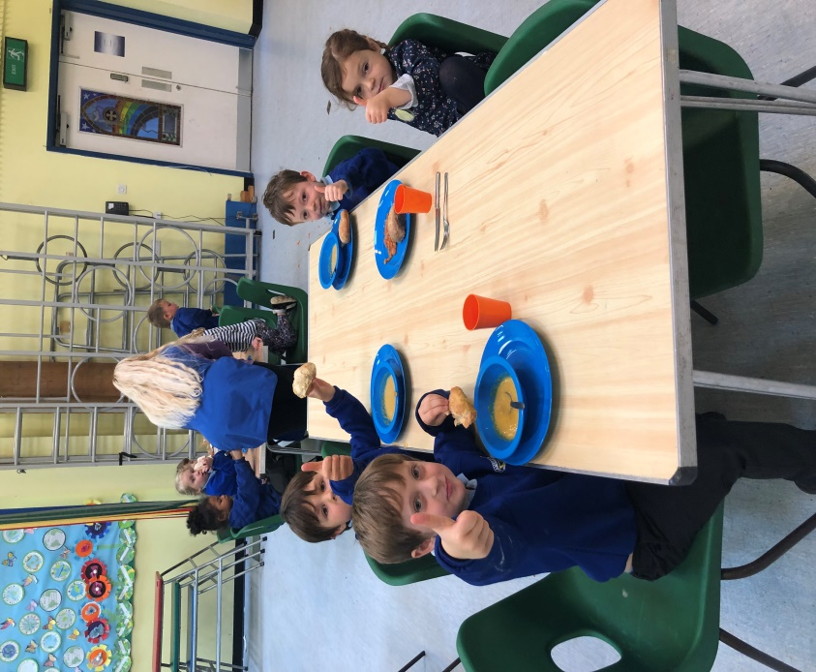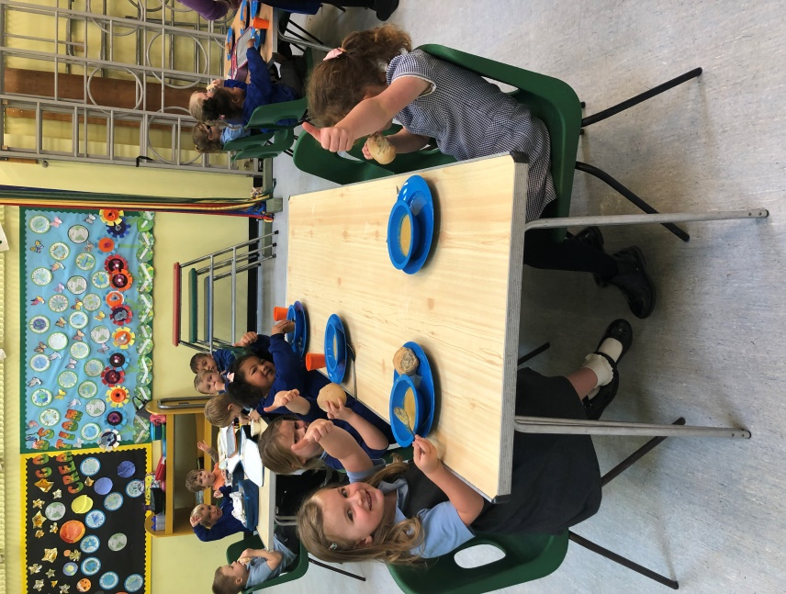

Exciting News
A drama group in Bristol, St Albans Players, have decided to put on a show that will be entered into the Bristol One Act Drama Festival which is the first round in a national drama competition. There is a separate competition for youth which this show will be entered in to. This time, and I think for the first time, they entered a children only performance and Rosie (from Rowan class) went along to do a couple of readings and decided to audition for the part of Daisy. The fabulous news is that Rosie has been given the role .
A comment was made by the audition panel on how well they thought Rosie had come on since November last year when she was in Goodnight Mr Tom – which was nice to hear, particularly as this person has experience in the entertainment industry in his working career via BBC TV.
The play is called ‘The Meadow’ and will be coming to the Bristol theatre in February 2020. We will let people know nearer the time the performance dates and venue details. Well done Rosie, this is such a great achievement!





