Personal, Social and
Emotional Development
Healthy Me

Create a healthy food plate- cut and stick activity/sorting activity- photo and observation
I can be healthy by…..
Oral Hygiene

Oral hygiene

EYFS
Term 4- Curriculum Map
Expressive Arts and Design 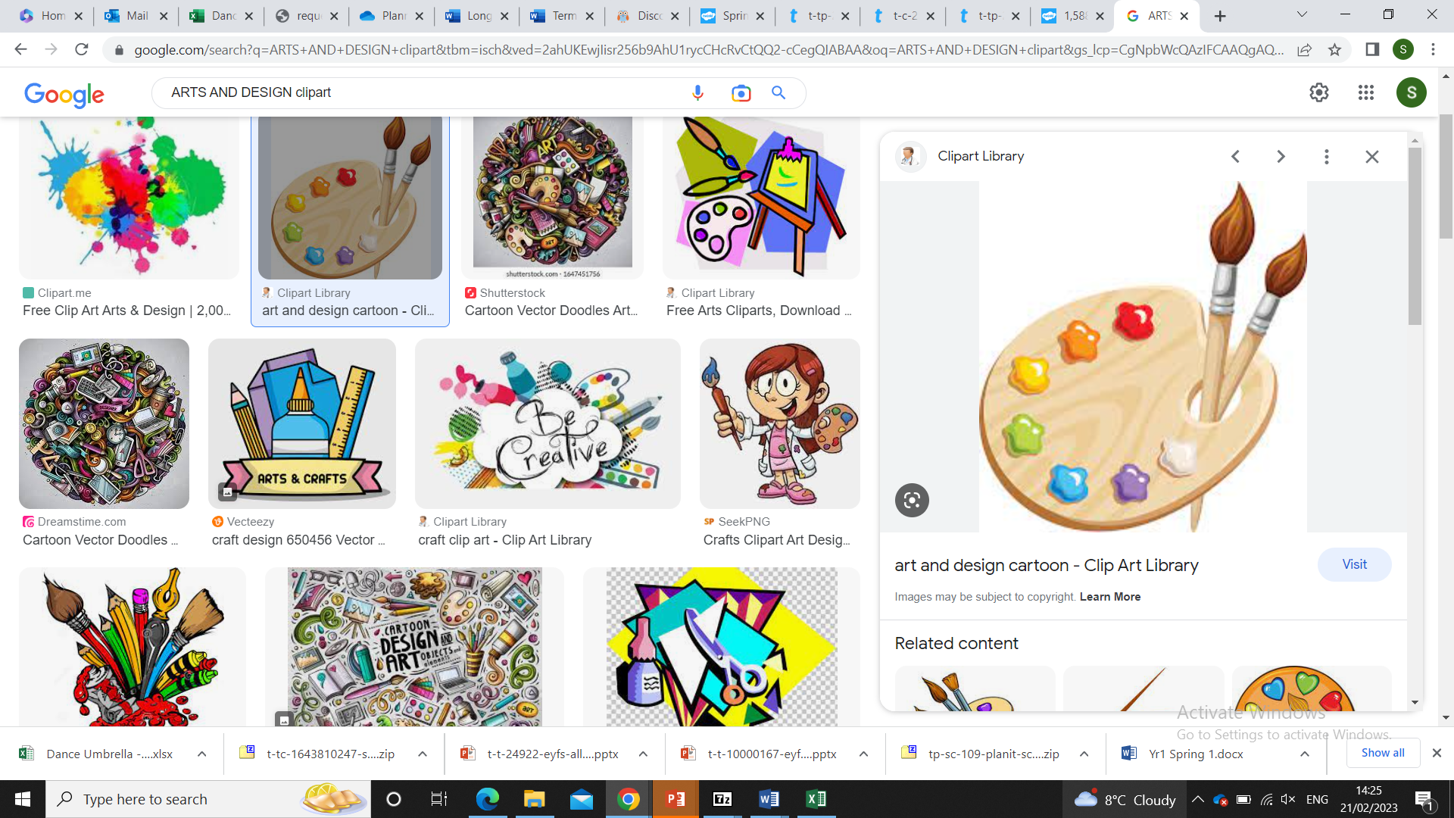

Painting and mixed media – Paint my World
Landscape inspired by Megan Coyle

Shape, line and colour, 3d Mixed media
Painting

Music- Our World
Discuss how a piece of classical music makes them feel

Physical Development 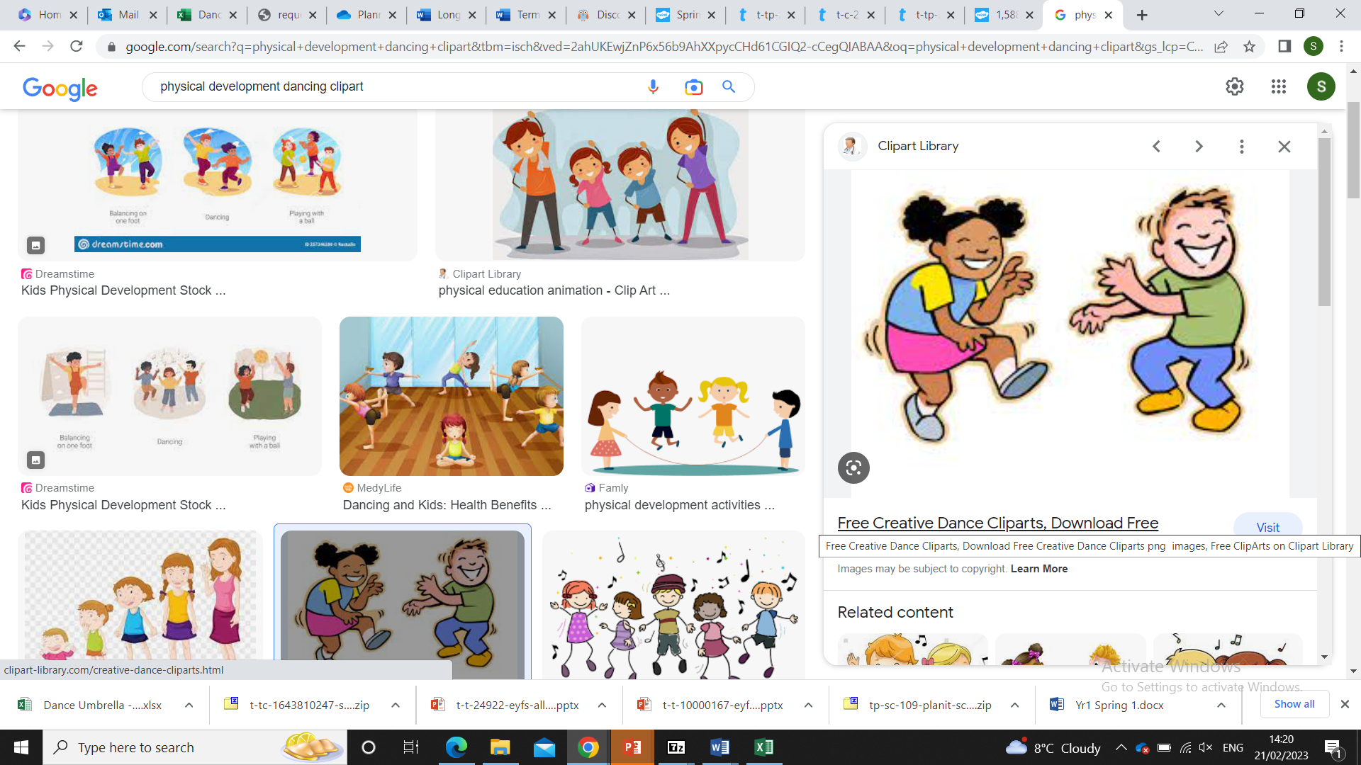
Dance
Control
Performance Coordination

Mathematics 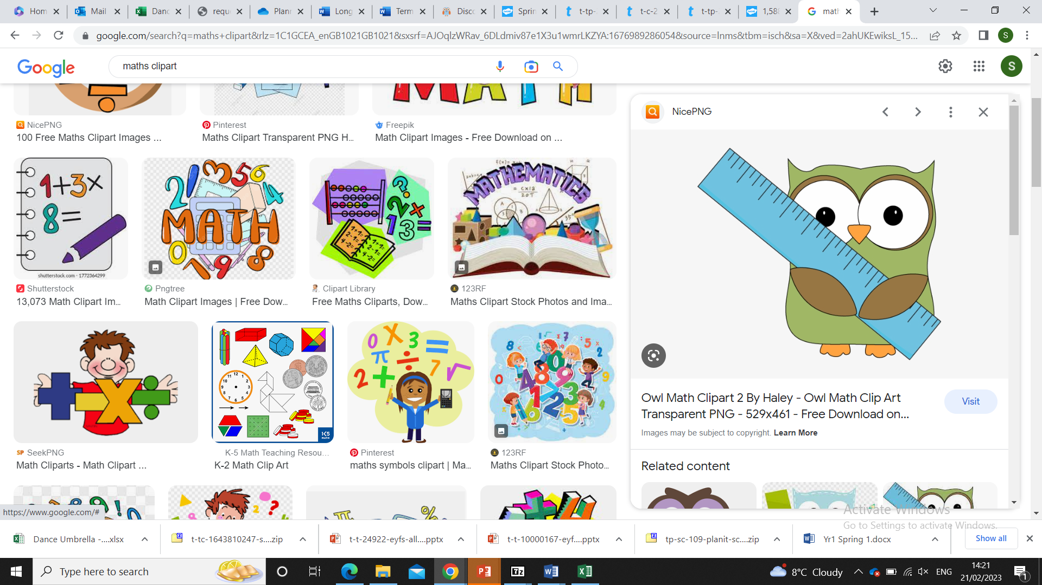
White Rose
Building 9 and 10

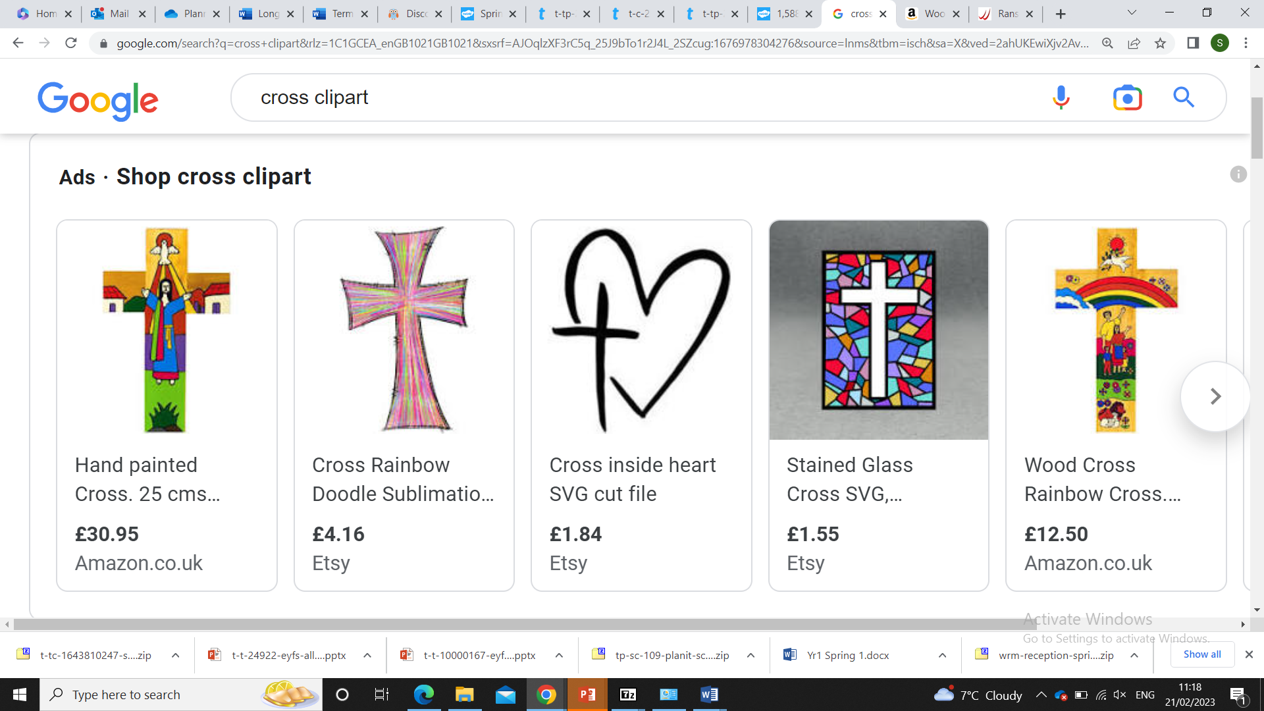Understanding the World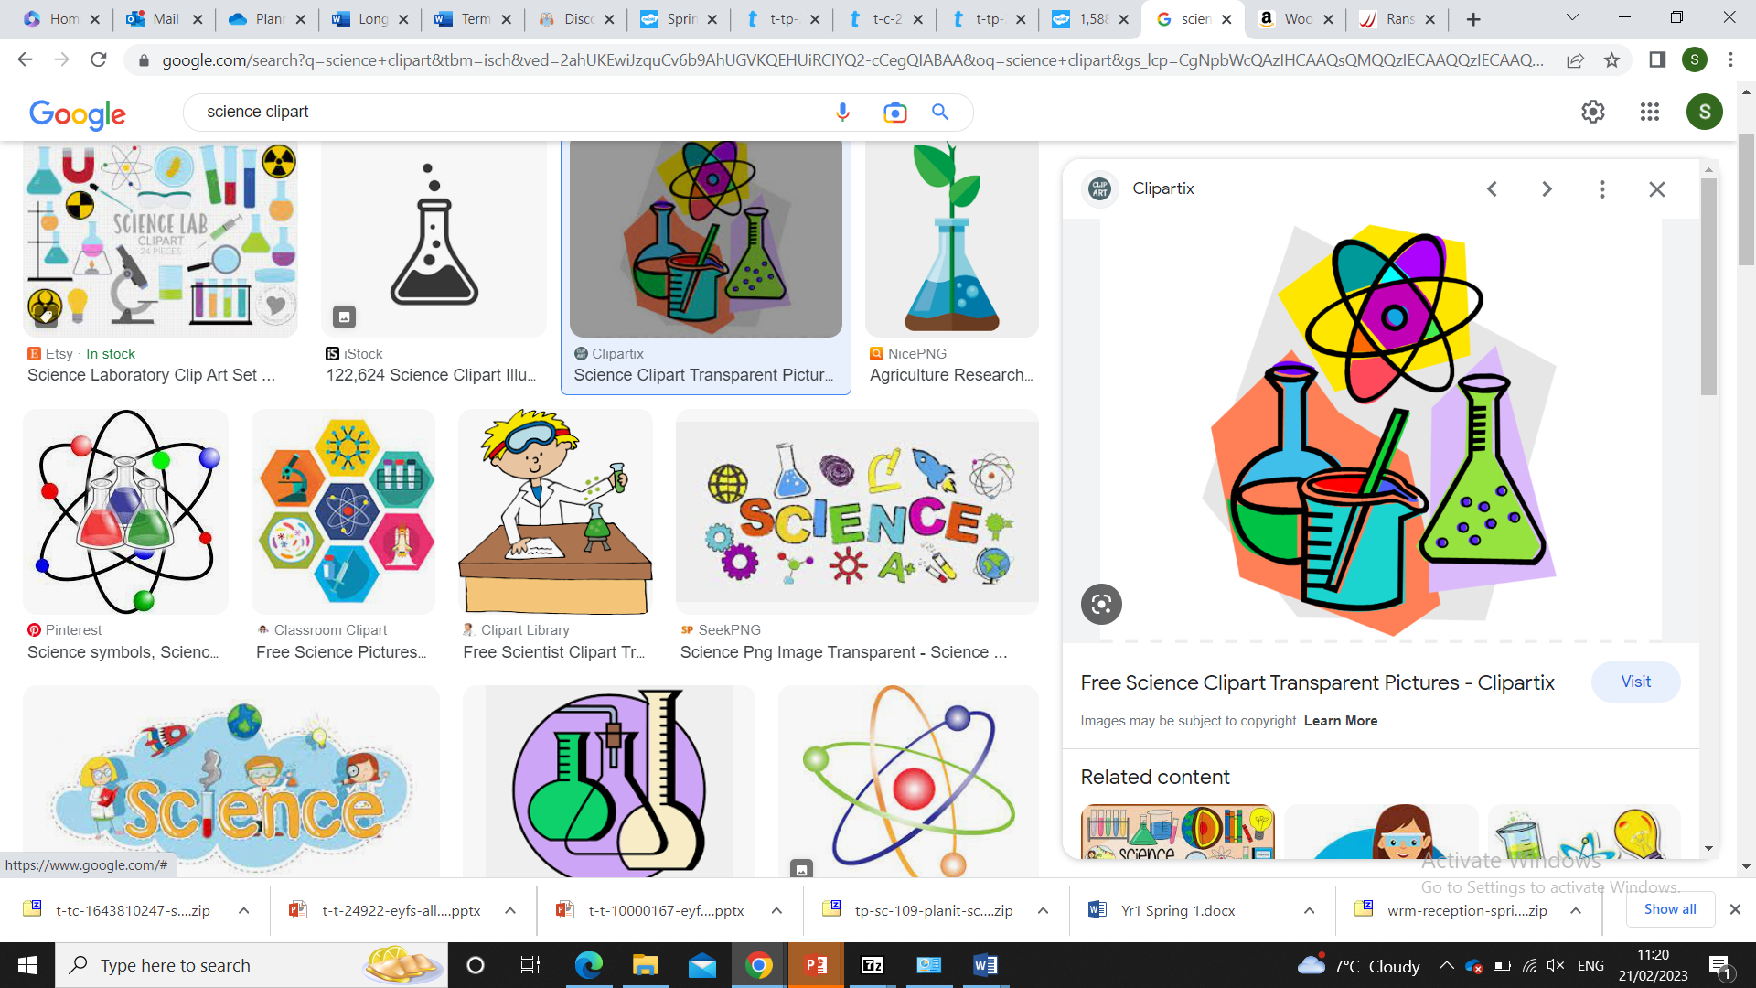
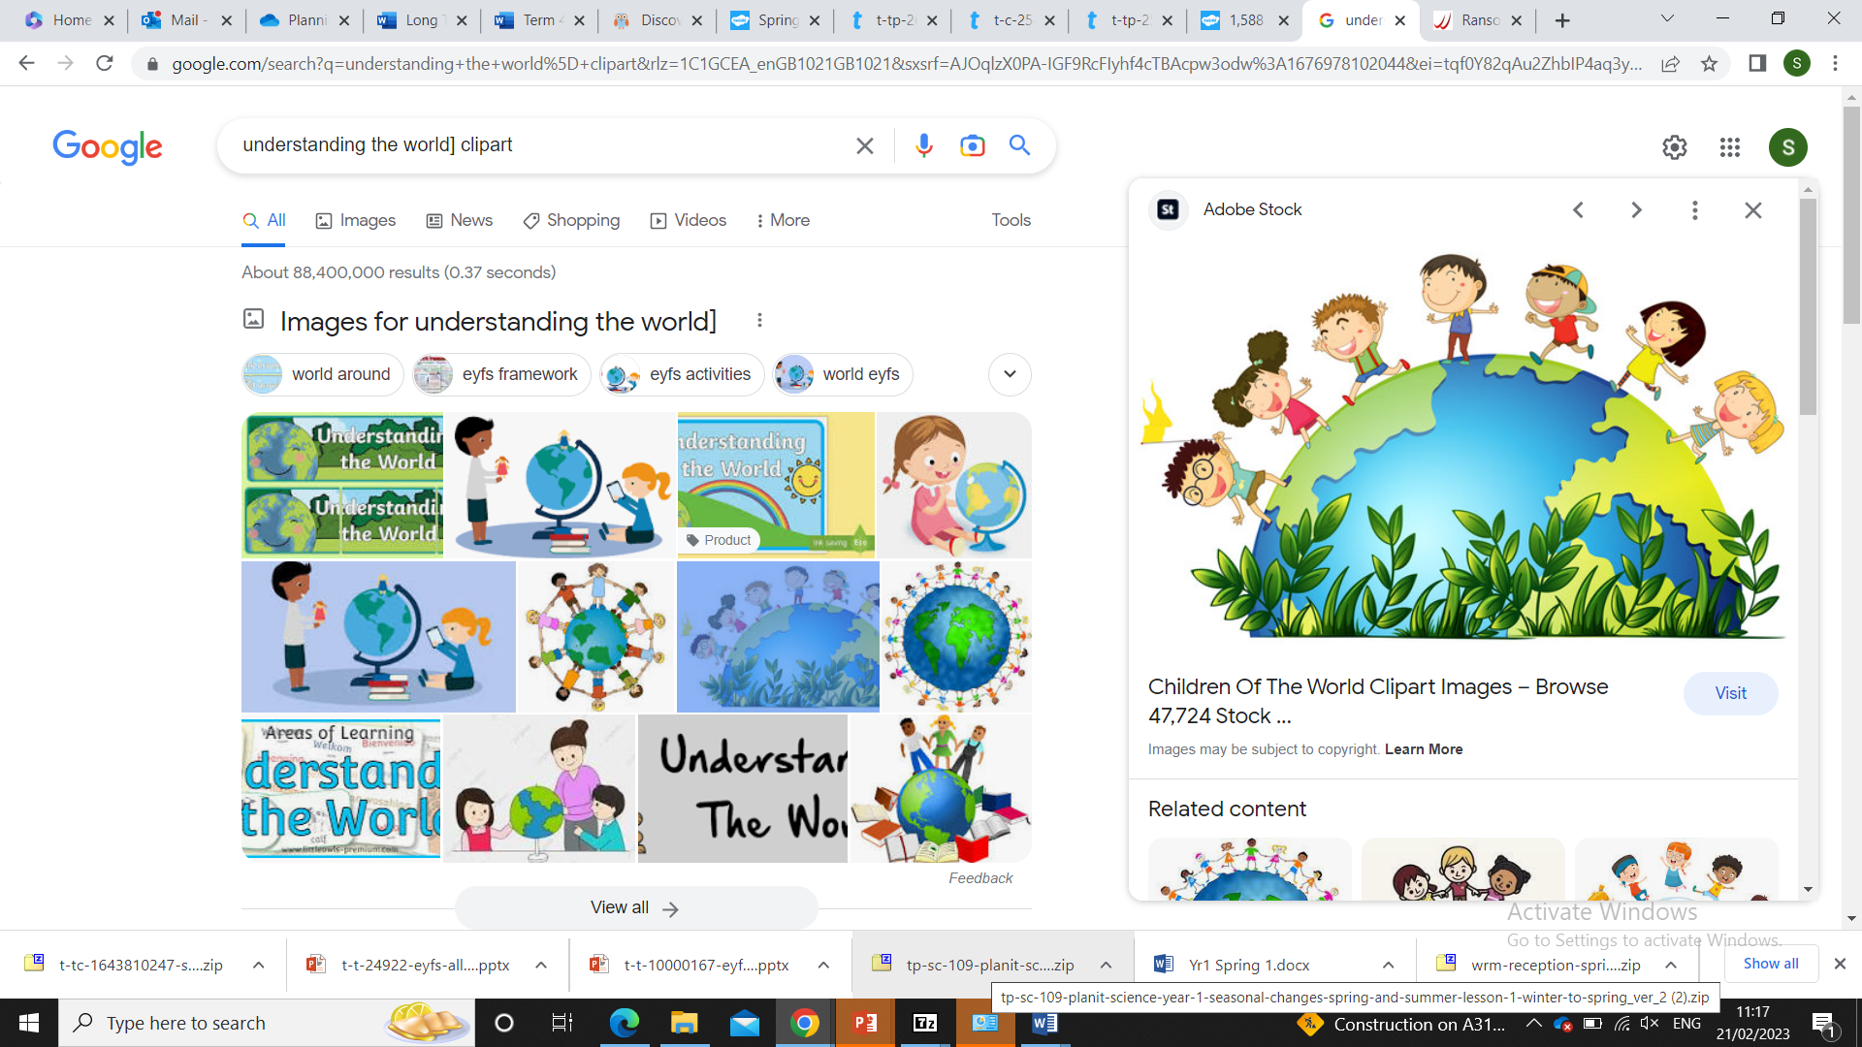
Science-
-Similarities and differences between this country and other countries
-Natural world -Seasons and change
Observing, Predicting

History-
-Describe the journey of Captain Scott.
-Compare how people travel the world today with Captain Scott's journey.
Migration

RE - Theme- Easter Religion: Christianity
Concept- Salvation
Key Questions: What is Easter?
Why do Christians put a cross on an Easter garden?

Literacy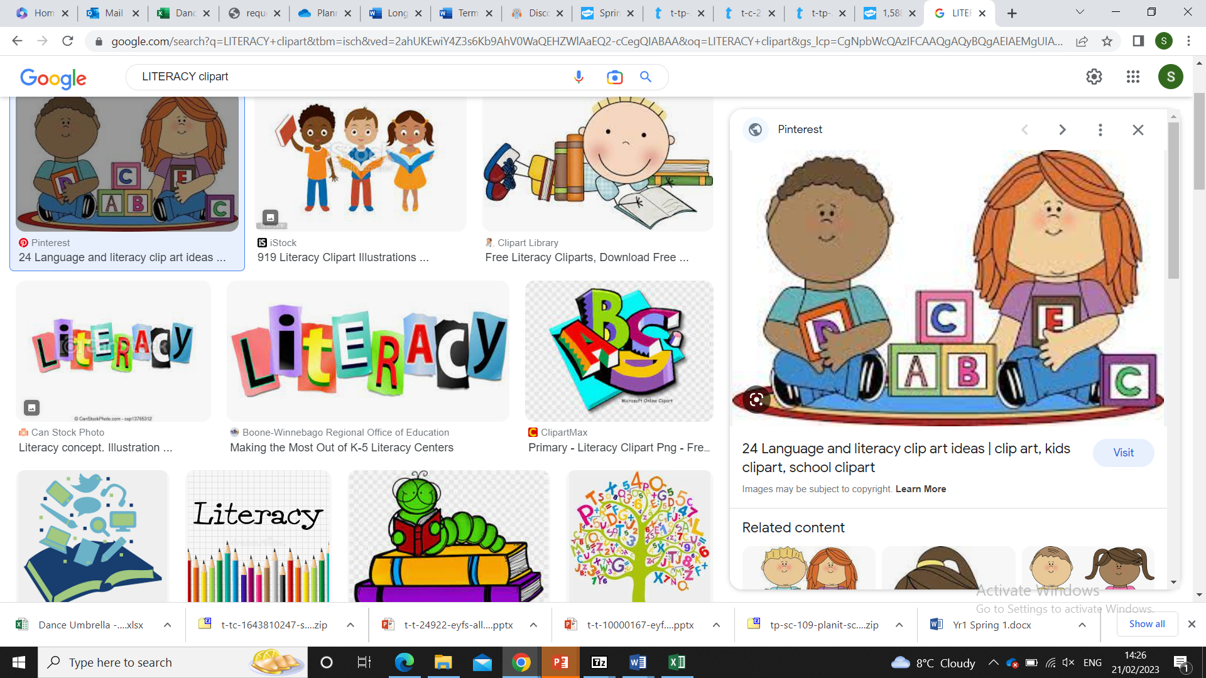

Astro girl by Ken Wilson-Max

Sentence construction

Fact file about Space

Communication and Language 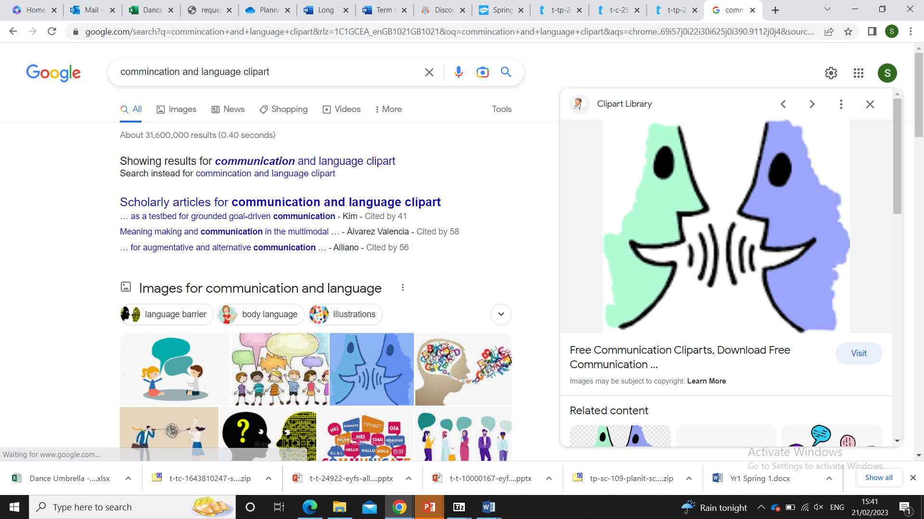
I can talk about a text – predicting what might happen and how a Character feels.
I can talk to my Teachers, friends and peers about what is important to me.
I can ask questions to find out more information.

Forest School
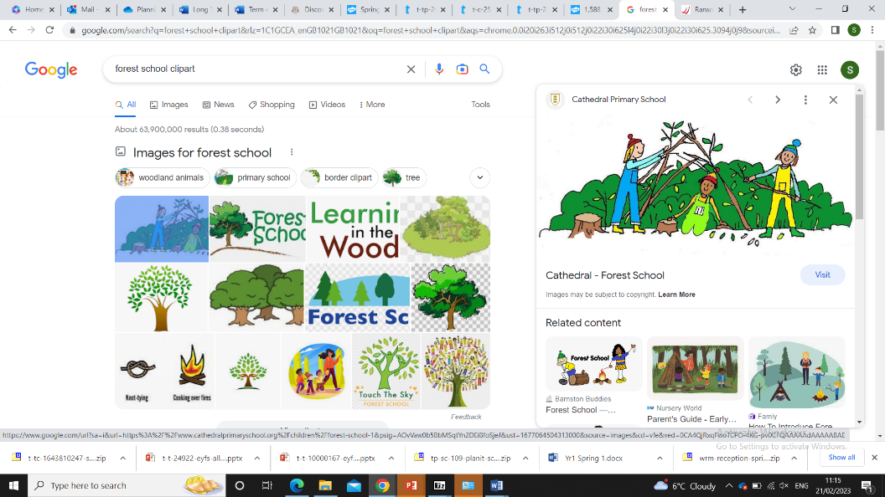
Exploring Spring & seasonal change

Using our senses to find signs of spring

Exploring mud and getting creative
What does spring mean for wildlife?

Stories about spring and new life

